TAMILNADUN MARGINAL WORKERS ANALYSIS

{Development Part}

Kapatralla Narendra naidu (team member)

Importing libraries and csv files:

Use the pandas.read_csv() function to load the data into a Pandas DataFrame. The data should contain information about the workers, such as their employment status, earnings, and other relevant characteristics.

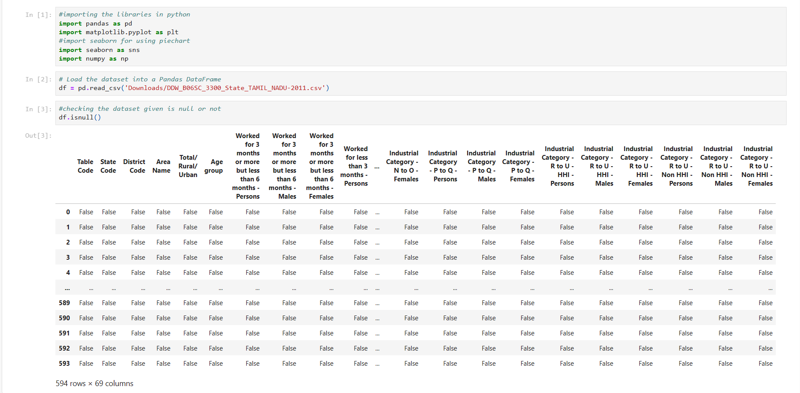

Fetching data from the imported csv file:

There is no single definition of a marginal worker, but they are typically defined as workers who are employed in low-paying jobs with limited benefits and job security. You can identify the marginal workers in your data using a variety of criteria, such as:

* Hourly wage below a certain threshold
* Number of hours worked per week below a certain threshold
* Type of employment (e.g., part time ,temporary,contract) 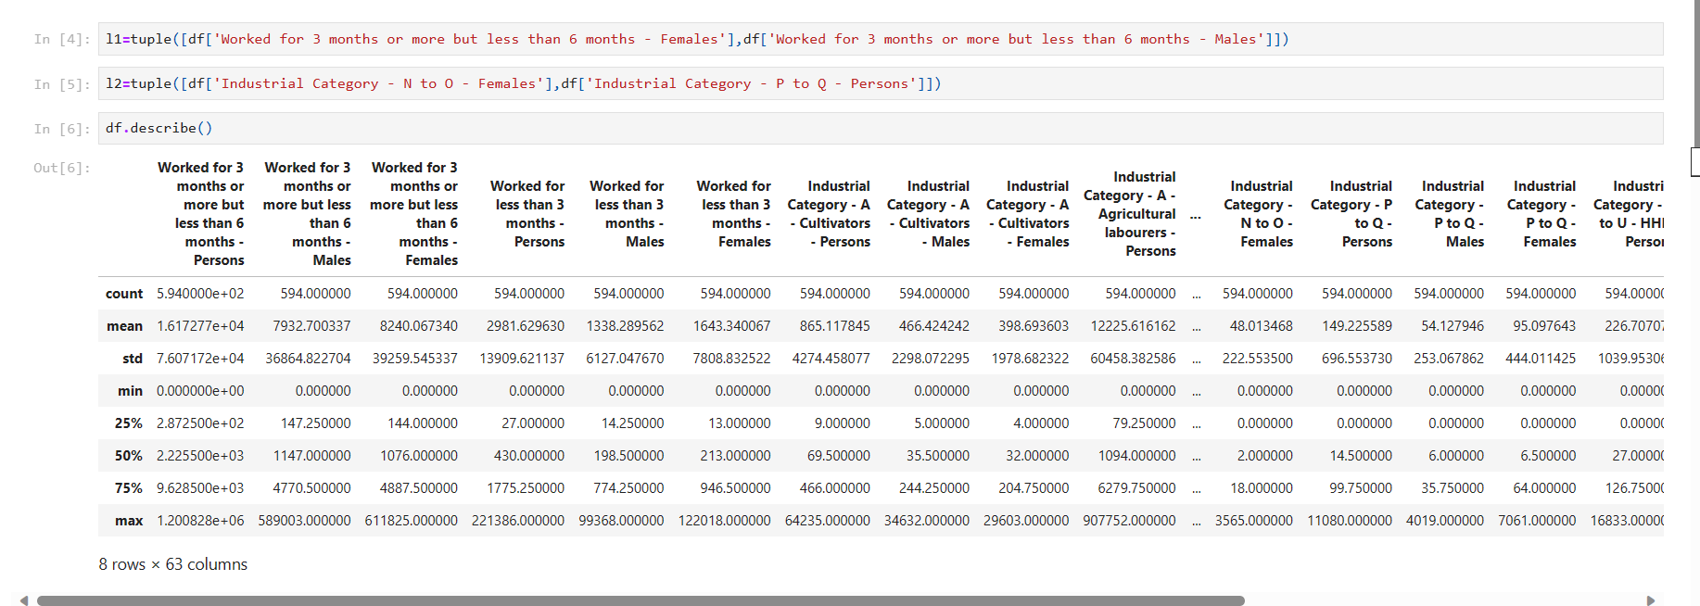

Retrieving the analysed data of the marginal workers:

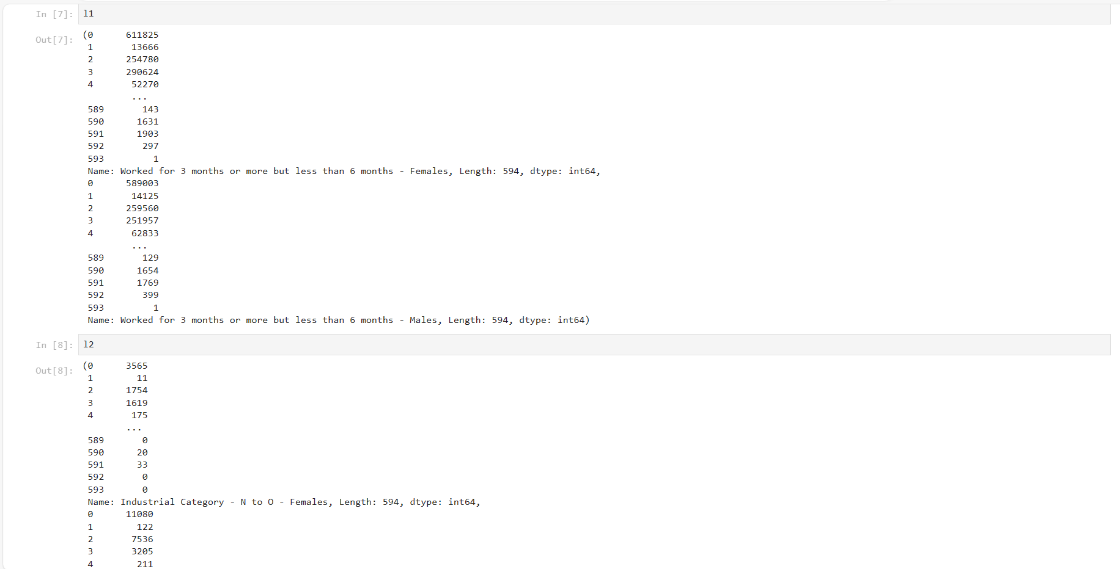

Creating pie chart code for the given csv file:

This code will read the CSV file into a Pandas DataFrame, extract the pie chart data, and create a pie chart. The pie chart will have the specified title and labels.

You can customize the pie chart by passing additional parameters to the matplotlib.pyplot.pie() function. For example, you can specify the colors of the pie chart slices, the explode values, and the start angle.

